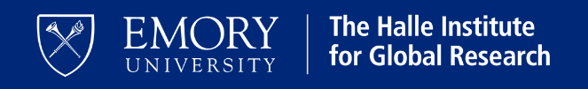

**Halle Institute Undergraduate Global Fellows**

**Advisor Support Document – Spring 2025**

Your advisee is applying for the Halle Institute Undergraduate Global Research Fellows (UGF) program, in partnership with the Pathways Center. Fellows in this program travel and conduct independent research in a non-US location during the summer of 2025.

The UGF program requires fellows to participate in a series of pre-summer and post-summer research-related workshops that aim to work in tandem with students’ advisors to provide support before and after field research.

Students are selected for this competitive funding program based on the strength of their research proposal, their demonstrated preparation for independent international research, and the stated support and involvement of their department and/or honors/capstone advisor. In lieu of a letter of recommendation, we require applicants’ advisors to complete this document for students to include in their applications, which are **due March 31, 2025**.

Please see the [Halle website](https://halle.emory.edu/students/halleundergrad.html), for the full call information.

Thank you for your partnership in supporting undergraduate global researchers! If you have questions, please contact Kelly Richmond Yates, [kyates2@emory.edu](mailto:kyates2@emory.edu).

***Note to students applying to Halle Global Fellows: This form serves in place of the “offer letter” in the Pathways application on Slate.***

**ADVISOR:**

**Please complete the following, sign, and return *to the student* for their submission.:**

Student Name:

Faculty Name:

Faculty Email:

Department:

Please provide responses to the following questions/considerations:

How do you know the student?

What abilities does the student bring to the project? Has the student demonstrated to you their readiness to pursue independent global research?

What are the merits of the project and/or potential significance of the proposed research?

How will you and/or your department help prepare the student prior to their research?

Please describe how you and/or your department will support the student while in-country. (*Students will travel independently and while Emory has safety and security systems in place to support students as needed, we also want to be sure students have regular contact with their department advisor to communicate about their research questions and progress.)*

How will you, as the student's advisor, work with the student upon their return to campus?

__________________________

Advisor Name

__________________________

Signature

__________________________

Date